|  |
| --- |
| SCORE ACADEMY |
| HIGH SCHOOL |
| *Building Pathways* |

Finding your Next Career

&

Nailing the Interview

Contents – use “Control+Click” over the page #s to be taken to that section.

**I.** **Finding the Career for Me!** 2

A. O*Net Online – Career Information 2

1. Career Interest Profiler 2

2. Occupation Search (when you want to explore various careers) 4

**II.** **Acing the Interview** 6

A. Job Search Resources 6

B. Application Templates and Interview Tips 7

1. Job Application Templates: 7

2. Common Questions that you may be asked during an interview: 7

3. Questions you may want to ask the employer: 8

4. Dress to Impress 8

5. Interview Tips: 9

6. Tips for Interview Follow up: 9

7. Building your Portfolio 10

# **Finding the Career for Me!**

Finding the career you want can be a daunting task.

Here’s how to find a GREAT career that fits you and ace that interview!

## [O*Net Online](https://www.onetonline.org/) – Career Information

**Open your favorite web browser and navigate to:** [**O*Net Online**](https://www.onetonline.org/)

O*Net is a **FREE** service of the US Dept. of Labor (Employment and Training Admin.) and offers resources about occupation outlooks, requirements, and salaries in the United States.

### Career Interest Profiler

(when you need some guidance to find the right career)

On the right-hand side of the site, in the “I want to be a…” section click on the O*Net Interest Profiler to help find careers that fit your interests.

Time for Completion: ~ 5 minutes

Take the survey and discover careers that may fit your interests.

Explore one of the suggested careers by clicking on the name or choose “Find More Careers”.

### Occupation Search (when you want to explore various careers)

Learn more about a particular Occupation, such as:

* Job Description
* Tasks associated with the role
* Technology skills required
* Work Activities associated with the role
* Training and Credentials needed (at the state and local level)
* Education required for the role
* Pay and Employment info (state and local level)
* Job Openings (state and local level)
* Related Occupations

Example Screenshots are below:

# **Acing the Interview**

## Job Search Resources

Almost all career/job offerings can be found via online sites:

**Online resources for Students looking for jobs (FYI, these will require the student to create an account):**

<https://www.careeronestop.org/JobSearch/job-search.aspx> - this site contains additional resources such as:

* [practice job applications](https://www.careeronestop.org/Toolkit/Jobs/practice-job-application.aspx).
* [Negotiating your salary](https://www.careeronestop.org/JobSearch/Interview/negotiate-your-salary.aspx).
* [Salary Finder tool](https://www.careeronestop.org/Toolkit/Wages/find-salary.aspx).
* [Finding Training](https://www.careeronestop.org/FindTraining/find-training.aspx).
* [Does my career choice require a license?](https://www.careeronestop.org/Toolkit/Training/find-licenses.aspx)
* [Foreign Workers](https://www.careeronestop.org/JobSearch/FindJobs/foreign-workers.aspx).

<https://www.careerbuilder.com>

<https://www.ziprecruiter.com/high-school-jobs> - this one is great for high school students (especially those under 18)

<https://www.indeed.com/l-Raleigh,-NC-jobs.html?vjk=81df536f04e8ca64>

<https://www.linkedin.com/>

## Application Templates and Interview Tips

### Job Application Templates:

#### **Templates are embedded (click on the “W” document to open)**

#### These templates are in Microsoft Word format, here is how to open the templates if you don’t have Microsoft Office products on your computer.

#### 

#### Cover Letter Template



#### Resume Template (three types)



#### Follow-Up Letter (Thank you letter) Template



If you cannot open these embedded templates, there are additional templates available online.

(NC State University) at: <https://cals.ncsu.edu/students/cals-careers/find-a-job-or-internship/resume-cover-letter/>

### Common Questions that you may be asked during an interview:

1. Tell me about yourself.
2. Why are you interested in working for this company?
3. Tell me about your education.

1. Why have you chosen this particular field?
2. Describe your best/worst boss.
3. In a job, what interests you most/least?
4. What is your major weakness?
5. Give an example of how you solved a problem in the past.
6. What are your strengths?
7. How do others describe you?
8. What do you consider your best accomplishment in your last job?
9. Where do you see yourself in three years?
10. Think about something you consider a failure in your life and tell me why you think it happened.
11. How do you think you will fit into this operation?
12. If you were hired, what ideas/talents could you contribute to the position or our company?
13. Give an example where you showed leadership and initiative.
14. Give an example of when you were able to contribute to a team project.
15. What have you done to develop or change in the last few years?
16. Do you have any questions for me? (It is a good idea to have at least one question)

### Questions you may want to ask the employer:

1. What are the responsibilities and accountabilities of this position?
2. Can this position’s duties be expanded?
3. Please describe an average day on this job.
4. What is the history of the position?
5. Why is it vacant?
6. What aspects of this job would you like to see performed better?
7. What are the key challenges or problems of this position?
8. Where can I go from here, assuming that I meet/exceed the job responsibilities?
9. How would you describe the ideal candidate?
10. What are the employer's short- and long-range objectives?
11. What are some outside influences that affect company growth?
12. Where does the company excel? What are its limitations?
13. When and how will I be evaluated?
14. What are the performance standards?
15. With whom would I be working?
16. Who would be my supervisor?
17. Who would I supervise? (If appropriate for the role)
18. What is the department's environment like?
19. When will you make the hiring decision?

### Dress to Impress

Use their dress code to determine what to wear to an interview. This shows you have the drive to move up in life. For example, applicants interviewing for shift supervisor at Walmart may wear khakis and a polo shirt on the job. However, go the extra mile and impress the hiring manager by showing up in a button-down shirt and ironed pants.

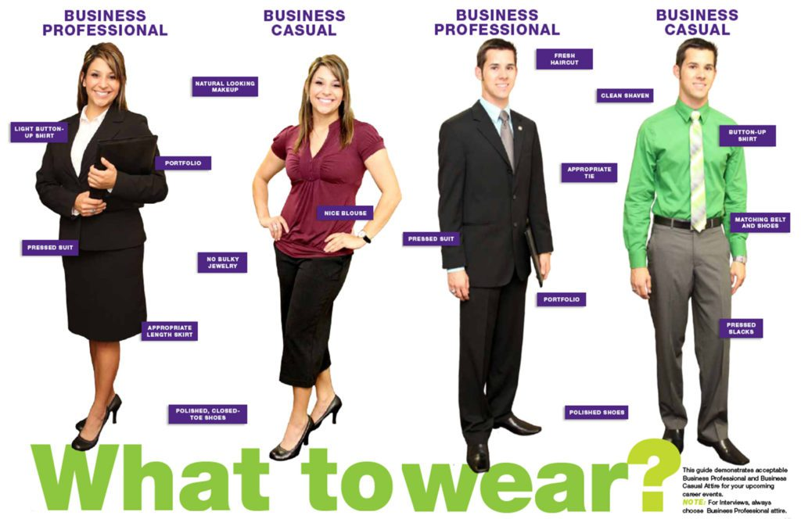

* Research dress codes for your position and industry.
* Look at the two immediate positions above you for inspiration.
* Dress for success, but don't go overboard.
* Wear neutral colors and stay away from patterns.
* Google interview videos to see the current trends.
* Consider comfort and climate at the office.
* Wear clothes you are comfortable with, not new, itchy suits that's never been worn.
* Break in your shoes.
* Always remove the tags after purchase.

### Interview Tips:

  1. Even if the company's dress code is casual, it is a good idea to dress up for an interview.

Take care to look professional, clean, and well groomed. Don't chew gum or smoke in the presence of your interviewers.

2. As an interviewee, you should learn about the company and job before the interview. The company's Web site is a great resource.  Be ready to talk about your experience and qualifications for this particular job. Bring a copy of any relevant portfolio materials (see below #6), particularly your resume and list of references.

3. Plan to get to your interview early, so that a little extra traffic, getting lost, or other unforeseen obstacles won't make you late. When you meet your interviewer or interviewers, introduce yourself, shake their hands, and use eye contact. Be polite and avoid using slang or inappropriate language.

4. Be prepared to summarize your experience in about 30 seconds and describe what you bring to the position (elevator pitch). Have hard copies of your resume available (with you) to hand to the interviewer(s).

5. Ask each person you interview with for their contact information (i.e., email address) so you can thank them for their time later. This is extremely valuable and will set you apart from other interviewees.

### Tips for Interview Follow up:

1. Open with a formal salutation and address the hiring manager by name.
2. If you interviewed with several people, send a separate follow-up note to every one of them. You can email the interviewer or mail them a hard copy letter (see attached) or email.  A hard copy letter will help you stand out.



Embedded document, click to open.

1. [Express your appreciation](https://zety.com/blog/letter-of-appreciation-example) and reinforce your interest in the position.
2. In the follow-up, refer to specific company plans that you discussed during the interview.
3. Suggest how your experience and skills can help with their challenges.
4. Say that you’re willing to provide the hiring manager with any additional information if necessary and confirm when a final decision is to be made.

### Building your Portfolio

Depending on the type of career you want to pursue you may need to show your perspective employer a portfolio of your previous work. Professions such as:

* Advertising

* Architect/Architect Assistant
* Artist
* Cake Decorator/Baker
* Computer Programmer (also Gaming Design)
* Graphic Designer
* Interior Designer
* Make-Up Artist
* Model
* Photographer
* Website Designer
* Writer

[Google Sites](https://sites.google.com/new?tgif=d) – Free resource to create an online portfolio you can access during your review.

[How Google Sites works](https://support.google.com/sites/answer/6372878?hl=en). – this describes how to build a free portfolio in Google. These will function similar to online slides.

Example of Work Portfolio: [YouTube –“What is a Career Portfolio”.](https://www.youtube.com/watch?v=8nvfLEpnCB4)